An investigation of conservation-biased gap-penalties for multiple protein sequence alignment
Willian R. Taylor
Gene, Volume: 165, Issue: 1, November 7, 1995, pp.GC27-GC35
Abstract
Sequence conservation in a multiple sequence alignment(or profile) is often used to influence the alignment of further sequences onto the profile.
- Introduction
- Method
Gap-penalty function:
If residue I aligns with j and I-k+1 aligns with j-1
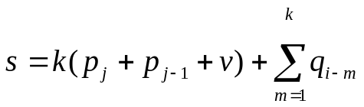
where p is the propensity of the ends of one sequence to be ‘broken’, q is the propensity of the other sequence to be inserted, and v is a constant.
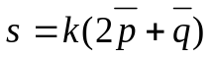
a length-independent formulation
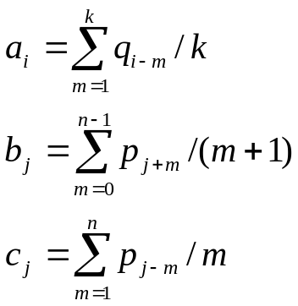
final scoring function
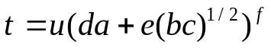
r = g/(1+t)
Relatedness matrix data
10M_{m} = (10 - m) 10I+ mD, m is a softness parameter, D is the PAM₁₂₀ matrix
- Results
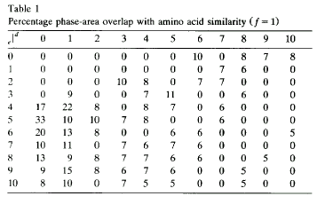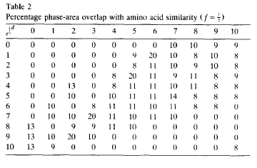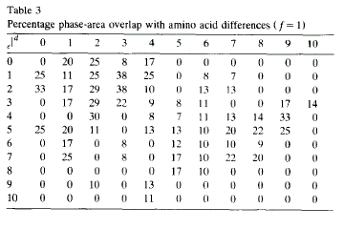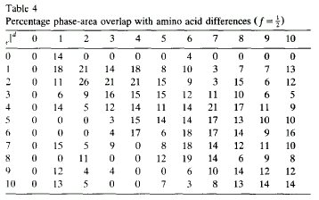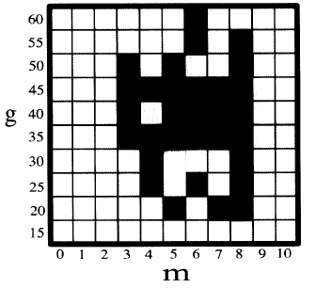
Created by: Ming-Cheng Lin
Date: July 5, 2000

